Lab Report 1 Date:2081/02/04

Experiment 1: Python Basics

Title: Programming to learn about python basics.

Objective:The objective of this lab-work is to provide a versatile, easy-to-learn, and powerful language that can be used to solve a wide variety of problems.

Theory: Python is a high-level, interpreted programming language known for its simplicity and readability. It emphasizes code readability and allows developers to express concepts in fewer lines of code compared to other programming languages.

1. WAP to print the “Hello World”.

*a="Hello world"*

*print(a)*

Output:



1. Create a program to input from user and delay it.

*a=input("Enter a String")*

*print(a)*

Output:



1. Write a program to add, subtract, multiply and divide two numbers.

*a=10*

*b =5*

*print(a+b)*

*print(a-b)*

*print(a\*b)*

*print(a/b)*

Output:

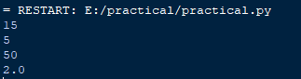

1. Check whether a given number is even or odd.

*a=int(input("Enter a number"))*

*if a%2==0:*

*print("It is even")*

*else:*

*print("It is odd")*

Output:

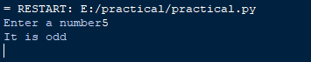

1. Find the largest among three numbers entered.

*a=int(input("Enter first number"))*

*b=int(input("Enter second number"))*

*c=int(input("Enter third number"))*

*if a>b and a>c:*

*print(a," is the largest")*

*elif b>a and b>c:*

*print(b," is the largest")*

*else:*

*print(c," is the largest")*

Output:

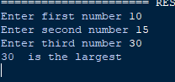

1. WAP to calculate the factorial of a number.

*a=int(input("Enter a number "))*

*fact=1*

*for i in range(1,a+1):*

*fact=fact\*i*

*i=i+1*

*print("The facorial of a given number is ",fact)*

Output:

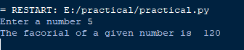

1. Generate the fibonacci series up to n terms.

*n=int(input("Enter the numbers"))*

*def fibo(n):*

*if n<=1:*

*return n*

*else:*

*return fibo(n-1)+fibo(n-2)*

*for i in range(n):*

*print(fibo(i))*

Output:

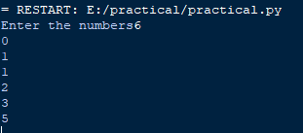

1. Check if a number is palindrome or not.

*a=int(input("Enter a number"))*

*b=int((str(a)[::-1]))*

*if b==a:*

*print("It is palindrome")*

*else:*

*print("It is not palindrome")*

Output:

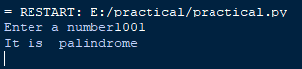

1. Create a program to find the sum of digits of a number.

*a=12345*

*sum=0*

*while a>0:*

*num=a%10*

*sum=sum+num*

*a=a//10*

*print("The sum of the digit",sum)*

Output:



1. Write a python program to check whether a given string is a palindrome.

*a=input("Enter a string")*

*b=a[::-1])*

*if b==a:*

*print("It is palindrome")*

*else:*

*print("It is not palindrome")*

Output:



Conclusion: In the above page we have done the basic python programming with its output .